

To keen on why Software industry need the Agile approach



Is another AIRLINE company



Todays world who is my future competitor not today.

So respoding to the change with quality is the key to survive for organisation.

Survery show fast moving and adaptable and get the time to market advantage

Example:





So the speed at which ,introduce the products and features in the market is more critical.

For sustaining the competitivitie advantage..

So Reduction of product development life cycle is strategic objective of technology driven firms





So requirements and business conditions are very volatile.

So it is very diffiuclt to derive the business decision from precise focus due to this volatility

Get ready for expecting the unexpected outcome is the mantras of success.

Take small steps

Evaluate and Adapt is the key for the success of this volatility

Summerize:



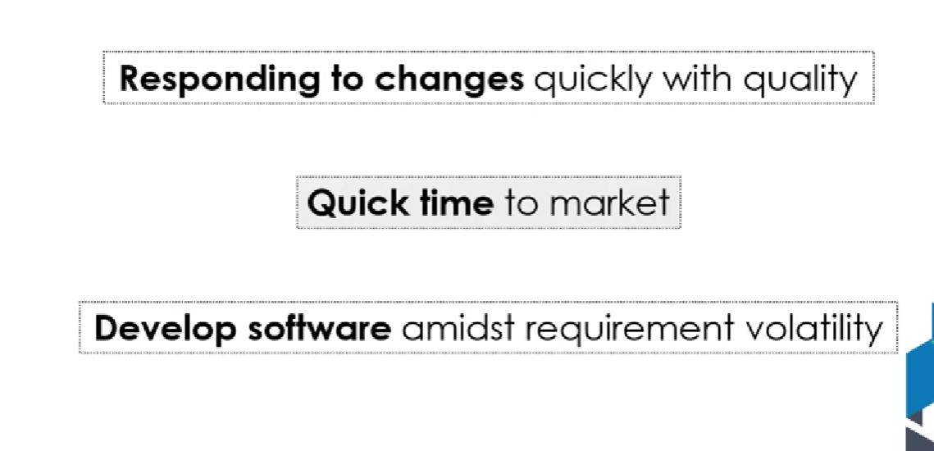

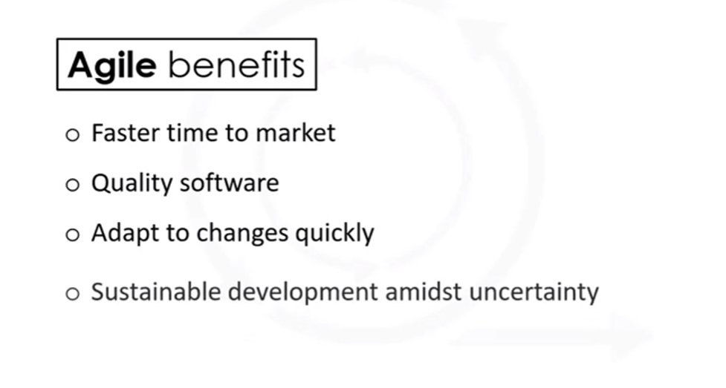

So moves the Agile software development today.

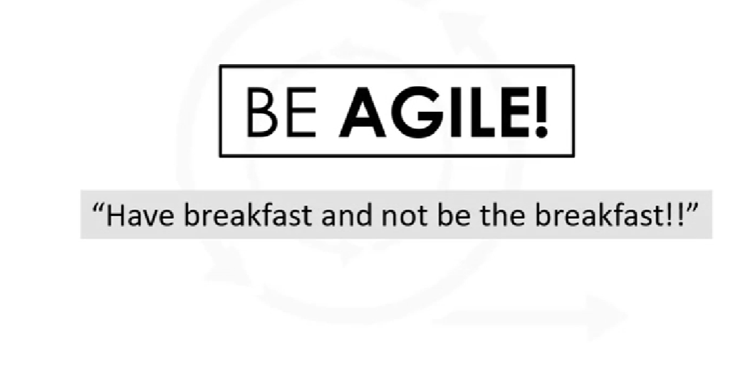

Agile principles:





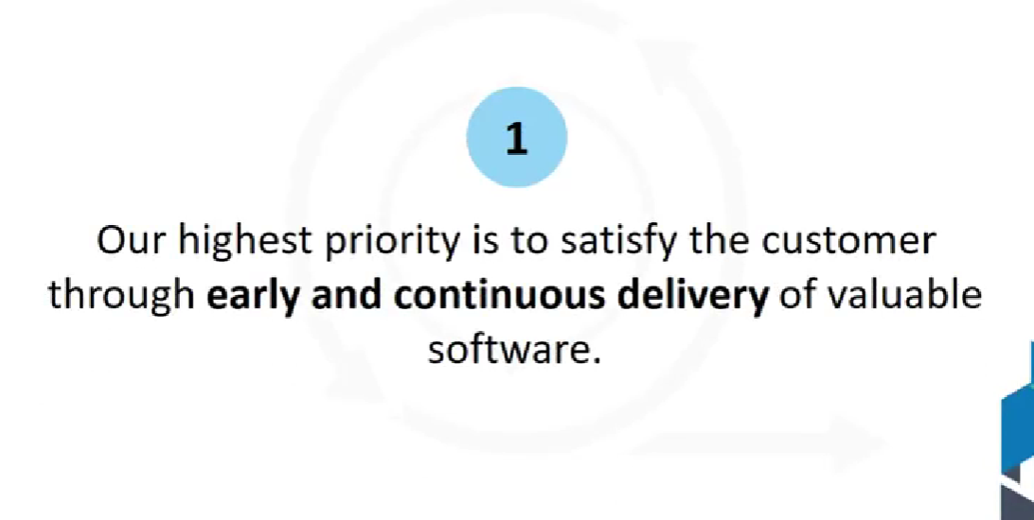

Leading online store in 1990 sell only one product later on they have bagged many products and become



Keep changing and having all customer all over the world



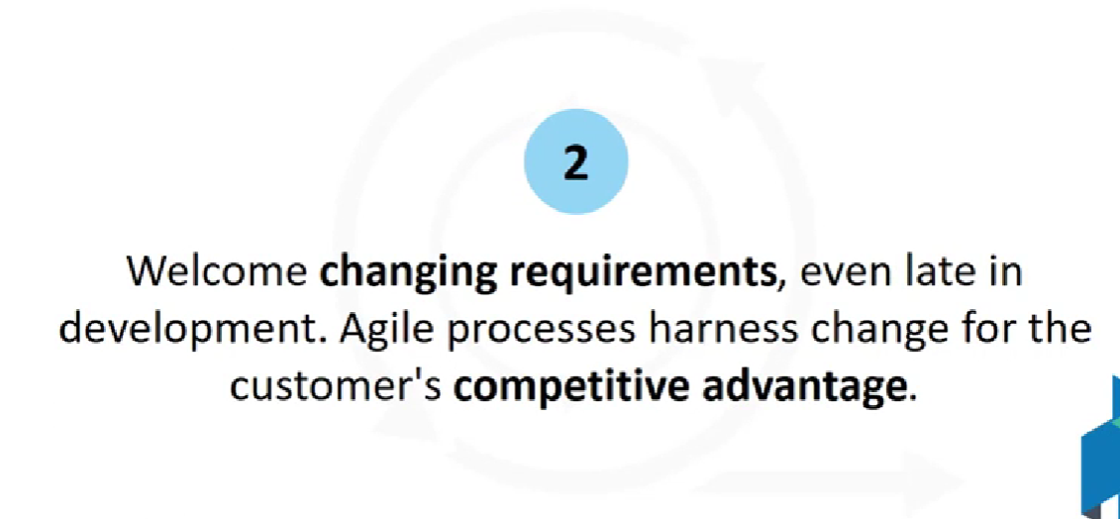





To buy a phone. How to take decision.

How customers are receiving the feedback. Not with humans and they are looking for the review and other ways. Before buying a product.

So it the responsibility of the developer team and business team to adapt the changes of the dynamic market changes.

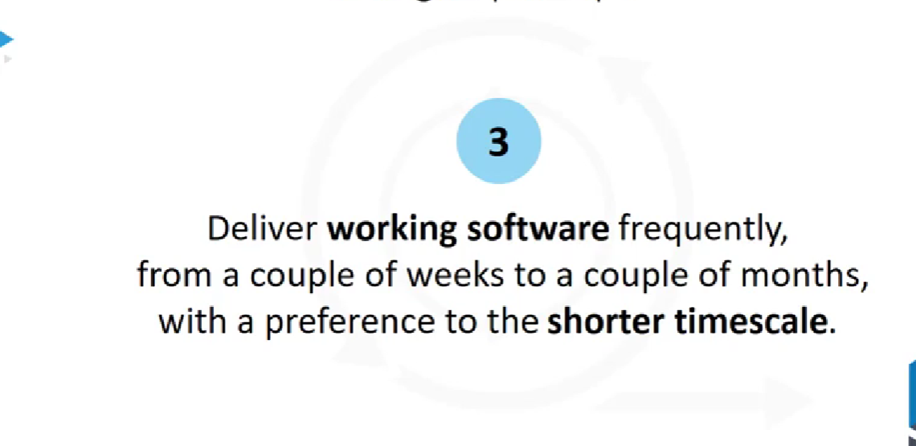



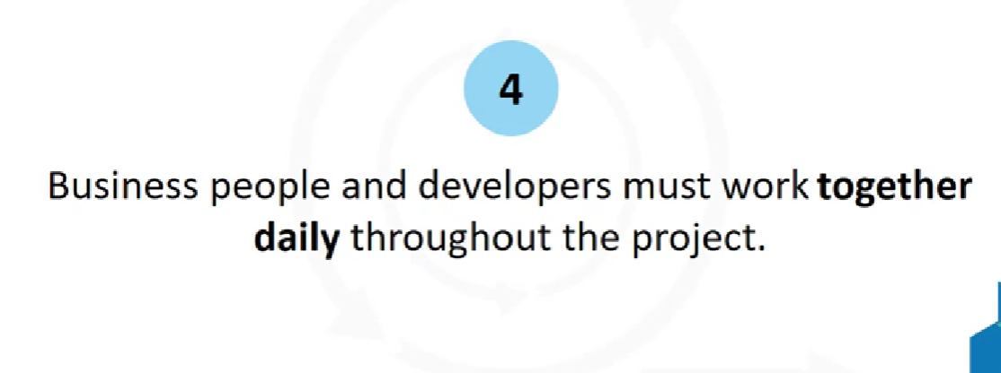

There is a conversation happened between the customer and technical team member through email.

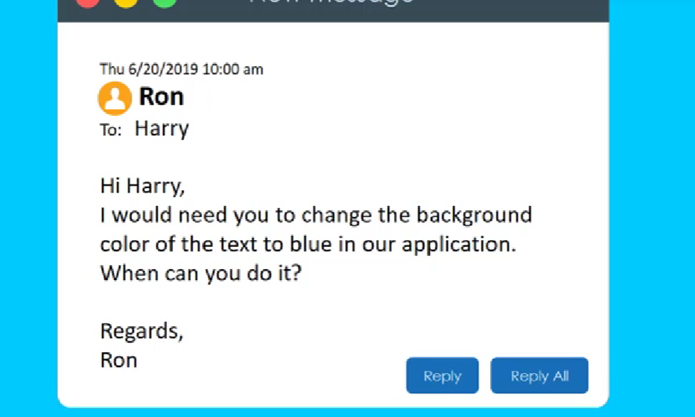

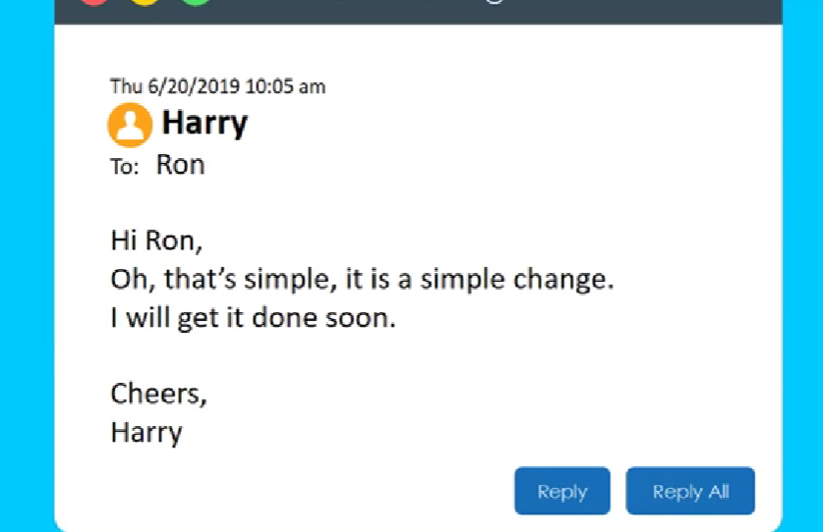

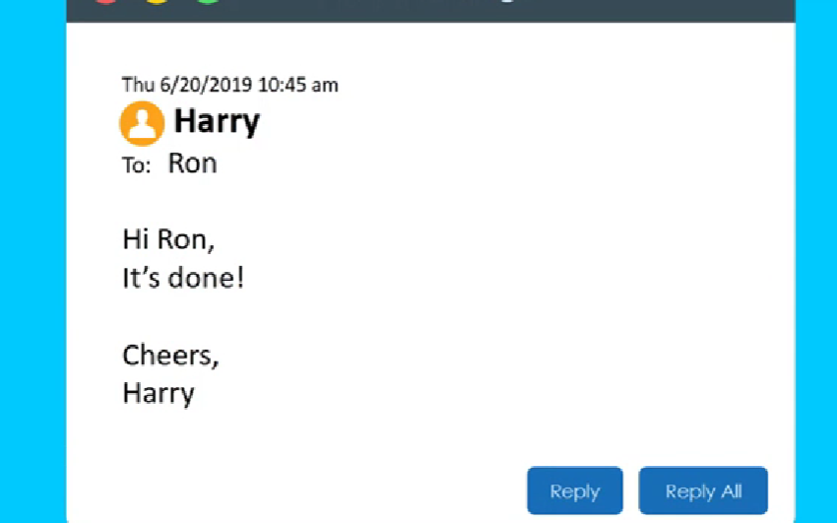

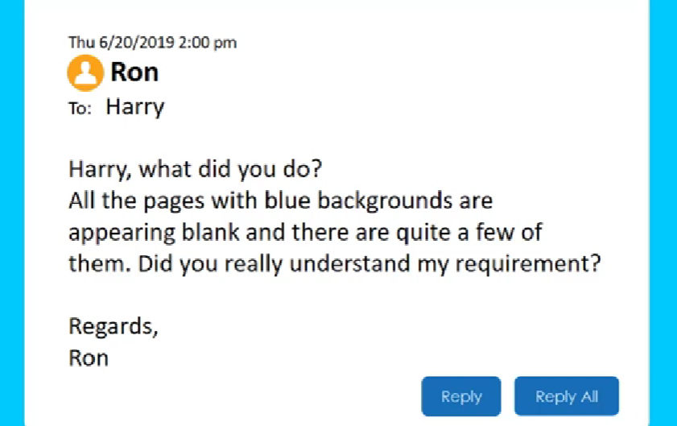

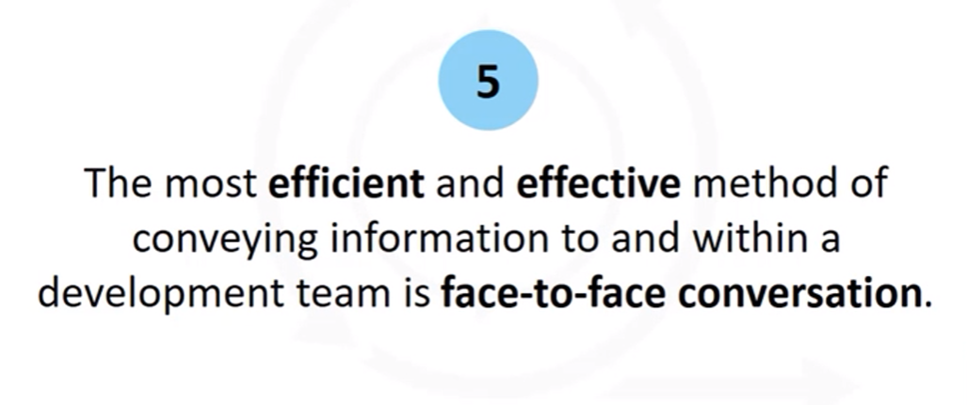

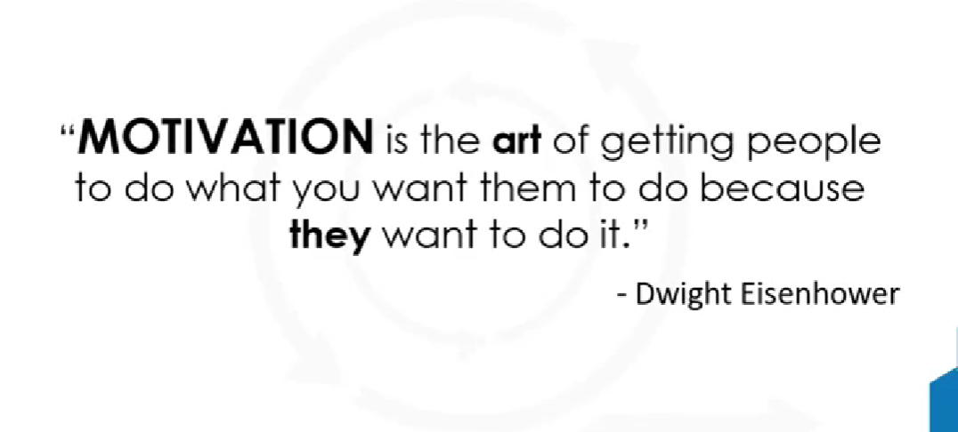

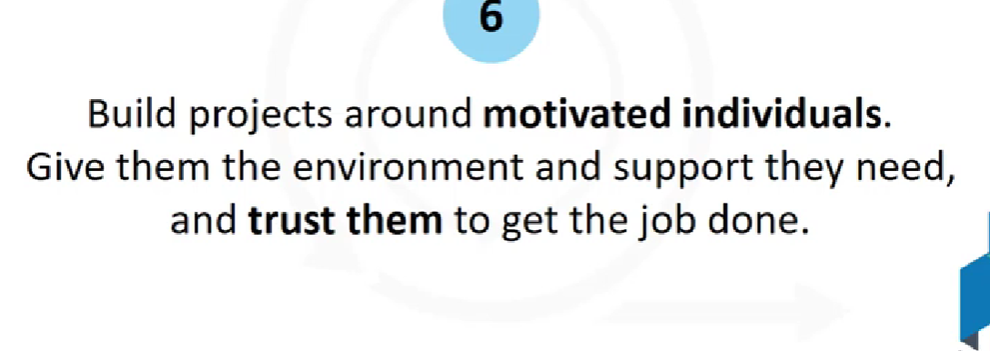

Feel collective owner ship of team and healthy environment





Can I claim 50 work is done.

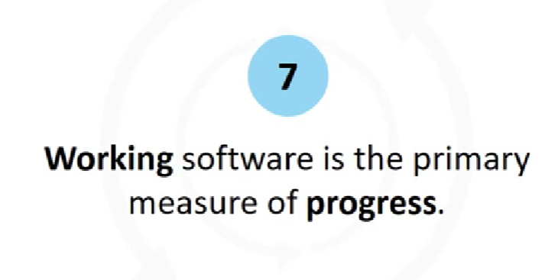

Progess is not measured by check the tasks and moving across the time lines.

By success how many tasks are deployed to use.



Marathon need a sustainable energy and speed to win.

First fast run and later on we cant have energy to run.

In the name of pace to meet the dead lines so don’t give unrealistic dead lines(SLA)

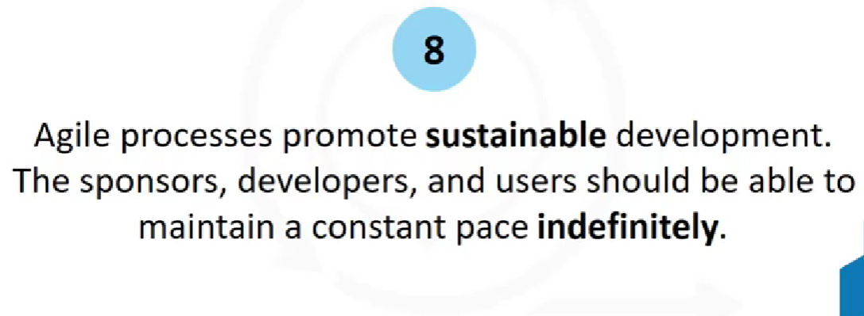



Easy Caeli has airline company and having its own IT desk to book tickes.

Steve family planned a vacation to Rome with family. At the time of booking they said seats are booked and given.



When they travel to airport and do checking the airlines told seats are given allocated to Paul.

Because of bad software.

What it he position of customer and we lost the valuable customer.

Focus on Good quality of code and continuous design.

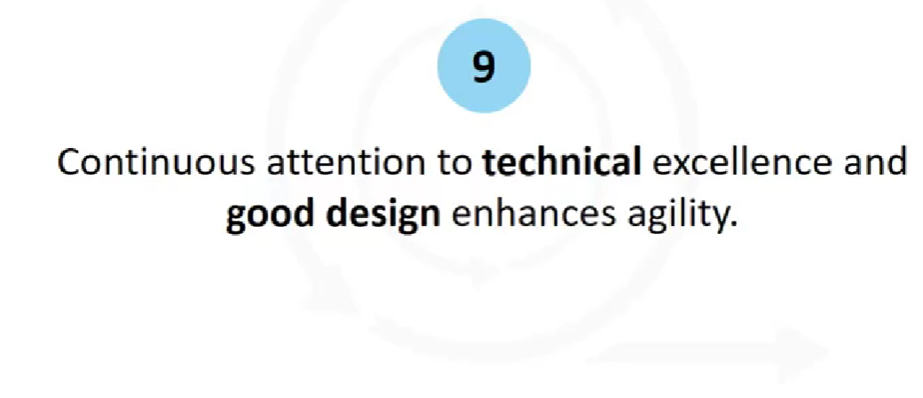

Smart phone software and how many features are using among:1/3 is not at all using.

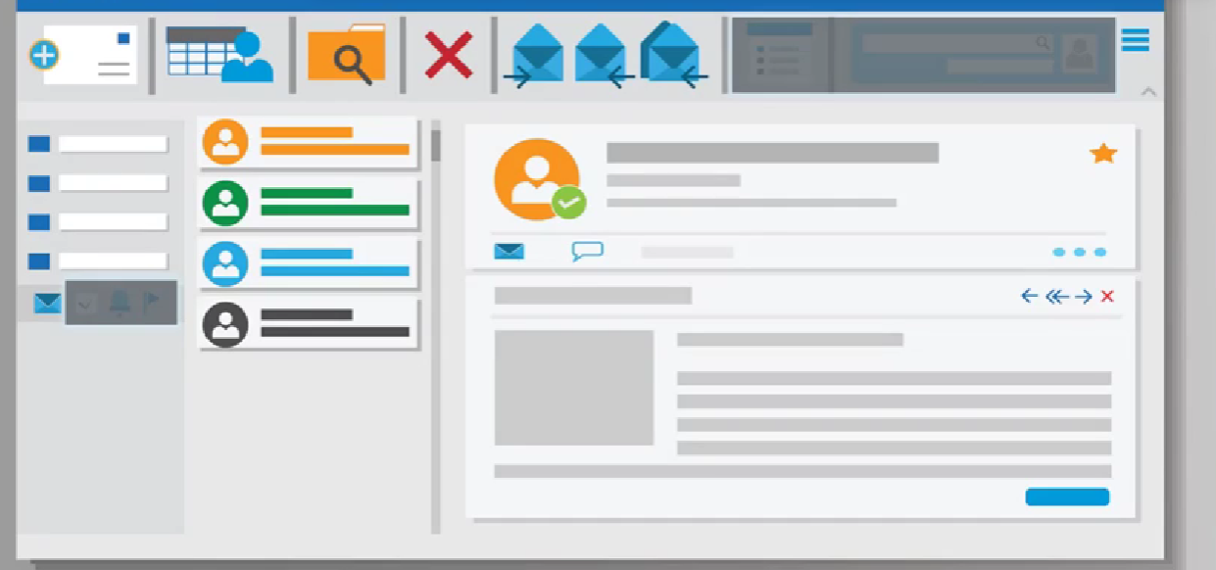

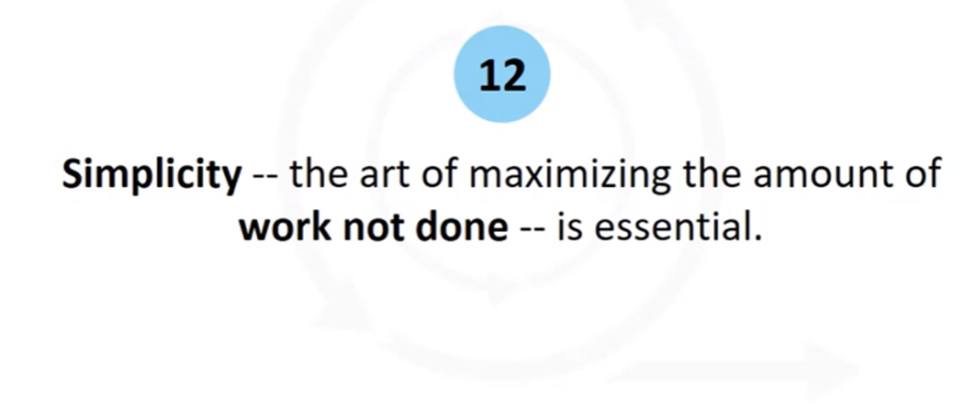

So eliminate the waste on unnecessary work and focus on needed important code.

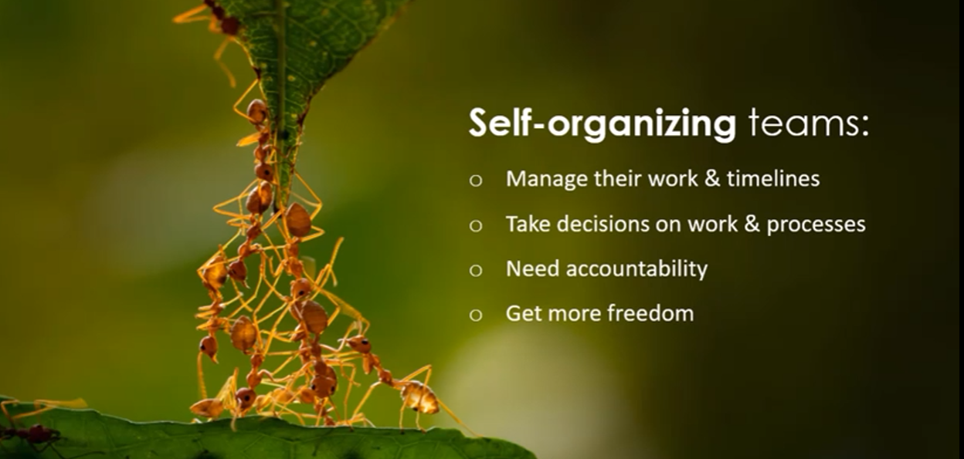

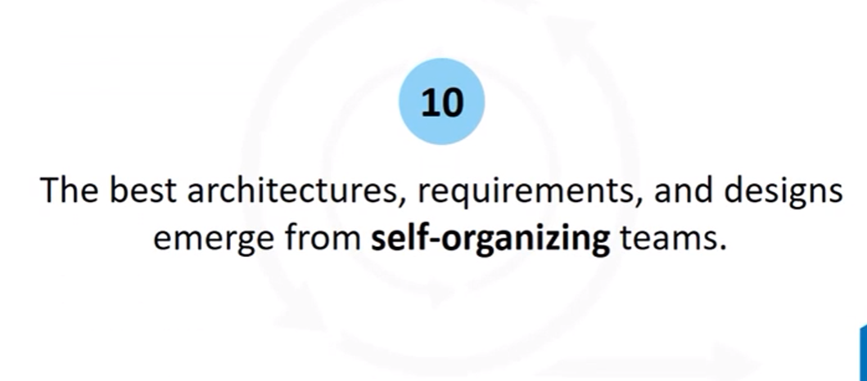

Automatic temperature controller AC in Home.

So sensor gathers the temperate and feed to the controller component.

So compressor on and off according to the room temperature.



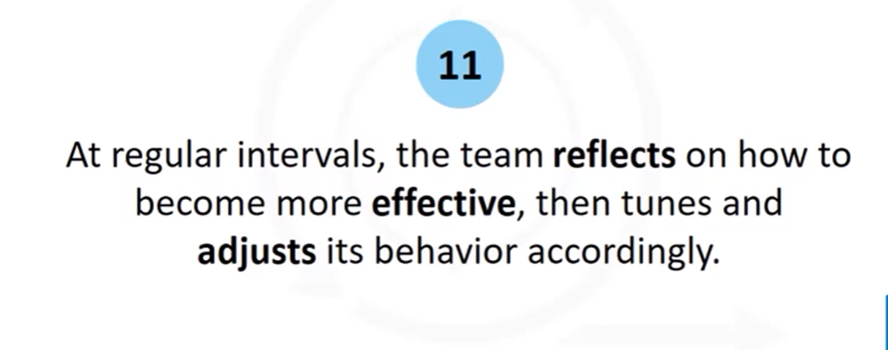

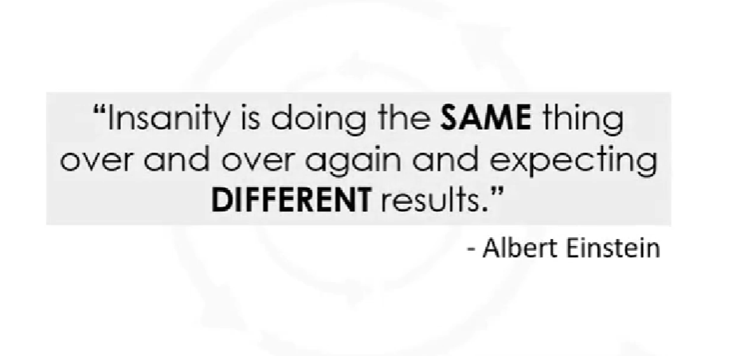

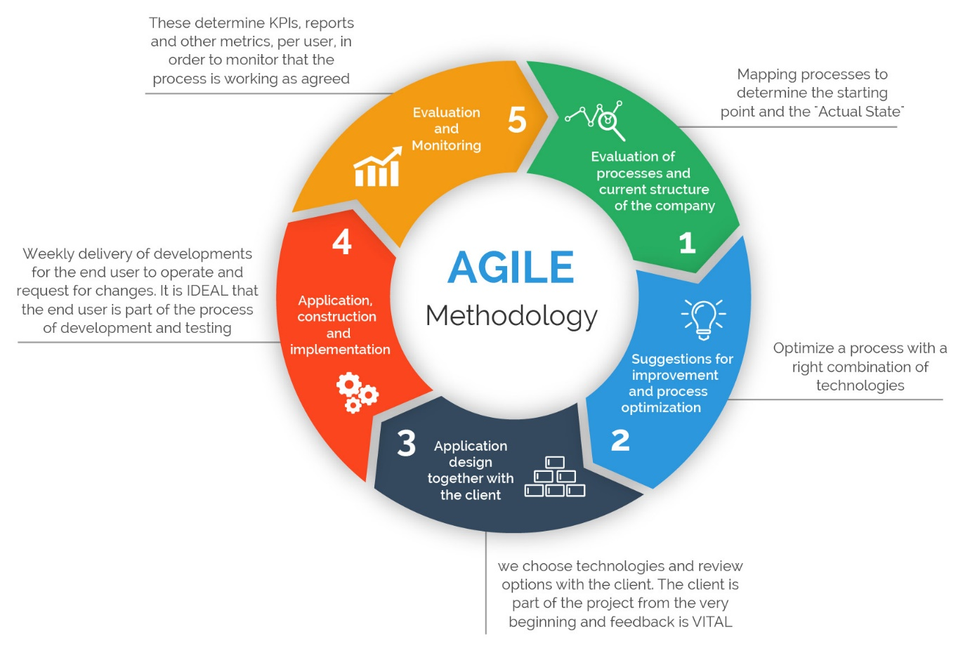

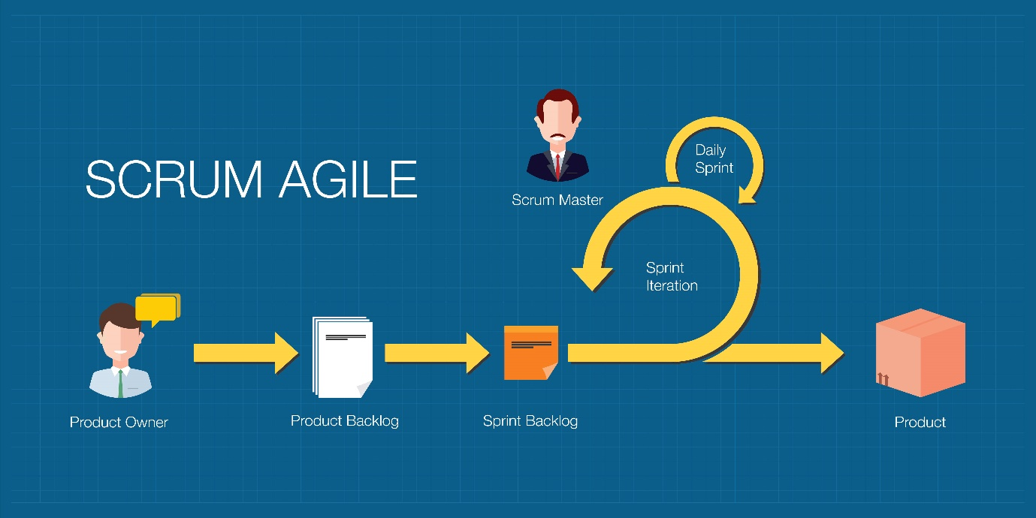

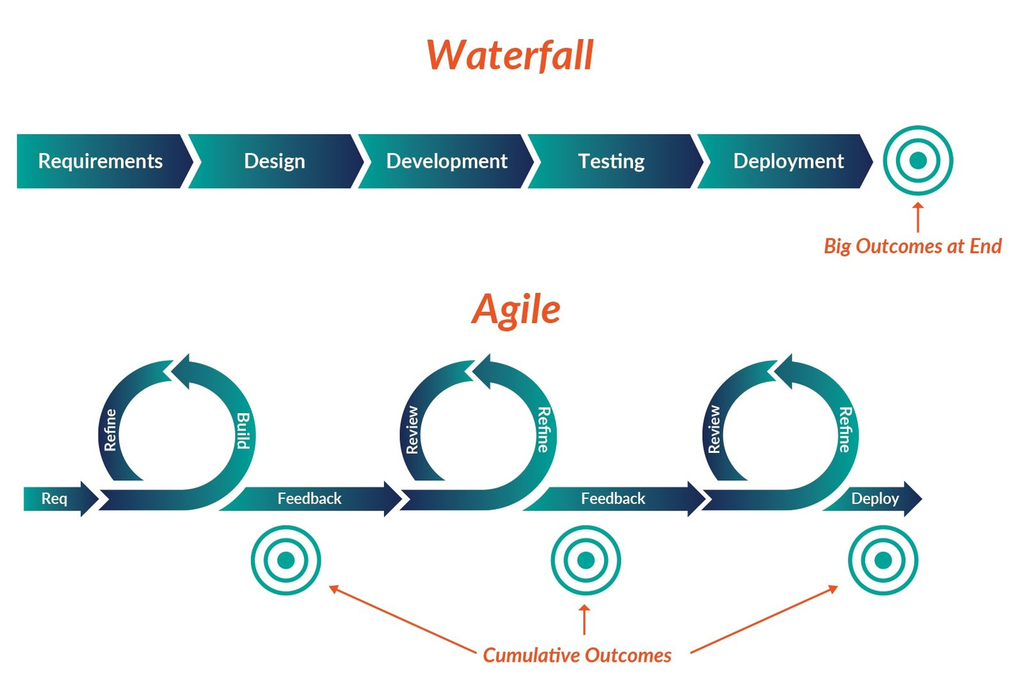

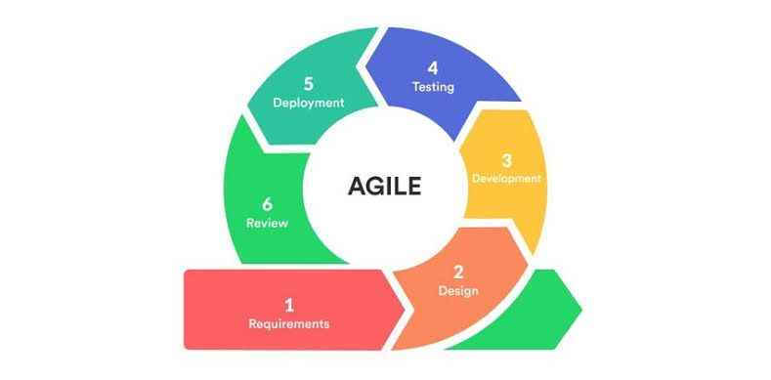

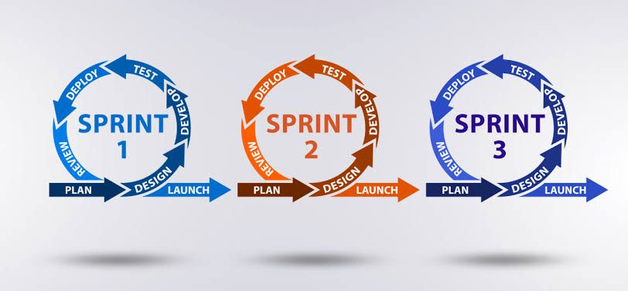

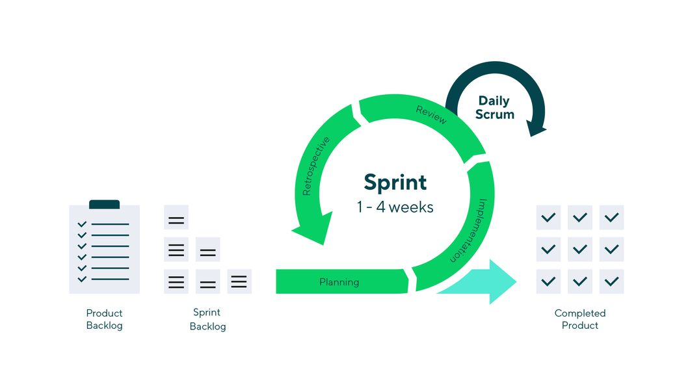

Extreme Programming (XP) is a software development methodology that emphasizes customer satisfaction, teamwork, and the frequent delivery of small, functional increments of software. It was created in the late 1990s by Kent Beck, Ward Cunningham, and Ron Jeffries, among others. XP is part of the Agile family of methodologies and is designed to address the challenges of rapidly changing requirements and dynamic software development environments. Here are some key principles and practices of Extreme Programming:

\*\*Core Principles:\*\*

1. \*\*Customer-Centric:\*\* XP places a strong emphasis on customer involvement. Customers (or their representatives) work closely with the development team to define and prioritize requirements. Frequent communication ensures that the delivered software meets the customer's needs.

2. \*\*Incremental Development:\*\* XP promotes the idea of delivering small, functional increments of software frequently. This allows for early feedback, reduces the risk of project failure, and enables the team to adapt to changing requirements.

3. \*\*Continuous Testing:\*\* XP advocates for continuous testing throughout the development process. Automated unit tests and acceptance tests are written before code is implemented. Code is only considered "done" when all tests pass.

4. \*\*Simplicity:\*\* XP encourages keeping the design and code as simple as possible. This helps prevent unnecessary complexity and makes it easier to adapt to changing requirements.

5. \*\*Feedback:\*\* Frequent feedback loops are integral to XP. Team members review each other's code, and customers provide feedback on the delivered functionality. This feedback drives improvements and corrections.

6. \*\*Courage:\*\* XP teams are expected to make difficult decisions, such as refactoring code, addressing technical debt, and making changes based on feedback. Courage is necessary to maintain software quality and meet customer expectations.

\*\*Key Practices:\*\*

1. \*\*Pair Programming:\*\* Developers work in pairs, with one actively writing code (the "driver") while the other reviews and provides immediate feedback (the "navigator"). Pair programming fosters collaboration, knowledge sharing, and higher code quality.

2. \*\*Test-Driven Development (TDD):\*\* Developers write tests before writing the code itself. TDD ensures that code is thoroughly tested, and it helps drive the design of the software.

3. \*\*Continuous Integration (CI):\*\* Code changes are integrated into the main codebase frequently, often multiple times per day. Automated build and test processes help catch integration issues early.

4. \*\*Collective Code Ownership:\*\* Everyone on the team is responsible for the entire codebase. This encourages collaboration, code sharing, and ensures that no single person becomes a bottleneck.

5. \*\*On-Site Customer:\*\* Ideally, a customer or customer representative works closely with the development team, providing real-time feedback and clarifications on requirements.

6. \*\*Small Releases:\*\* XP teams aim to release small, functional increments of the software as frequently as possible, typically every few weeks.

7. \*\*Refactoring:\*\* Regularly improving the design and structure of the codebase is essential to maintain code quality. Refactoring is an ongoing practice in XP.

8. \*\*Simple Design:\*\* Code should be kept as simple as possible. Simplicity reduces the chances of defects, makes it easier to adapt to changes, and improves maintainability.

Extreme Programming is known for its disciplined approach to software development, its focus on customer collaboration, and its ability to adapt to changing requirements. While it may not be suitable for every project or organization, it has been successful in situations where rapid iteration, close customer involvement, and high-quality code are essential.